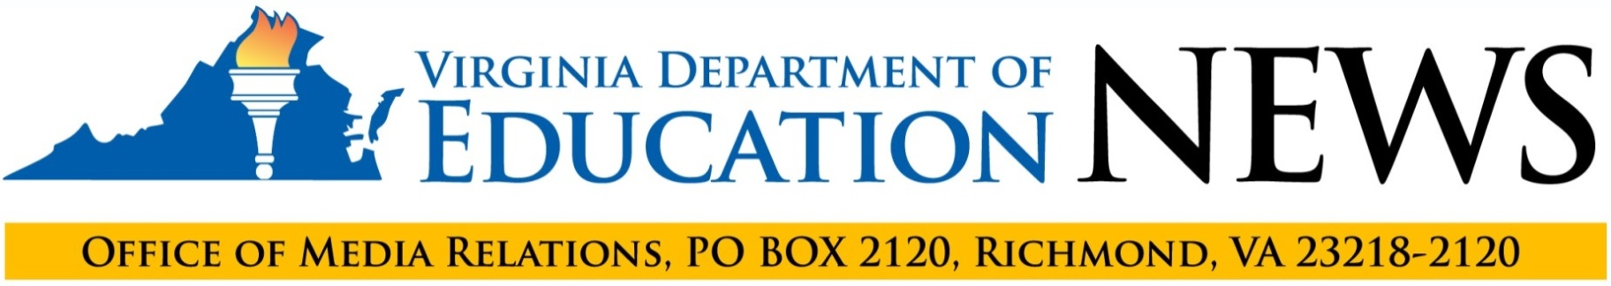

For Immediate Release: September 30, 2019
Contact: Charles B. Pyle, Director of Communications, (804) 371-2420

2019-2020 Accreditation Ratings Shine Light
on School Progress and Needs
92% of Virginia Public Schools Earn “Accredited” Rating

RICHMOND, Va. — Superintendent of Public Instruction James Lane announced today that 92% of Virginia’s public schools are meeting the state Board of Education’s expectations for achievement and improving student outcomes, and are accredited for the 2019-2020 school year.

The accreditation ratings reported by the Virginia Department of Education also show that schools are making progress in reducing chronic absenteeism, but that declines in performance on state reading tests — especially among black and economically disadvantaged students — have resulted in an increase in the number of schools that will receive state assistance to address achievement gaps in English.

“This is the second year that schools have been evaluated under the 2017 Board of Education-approved accreditation standards, and this new system for measuring the progress and needs of schools is doing exactly what it was designed to do,” Lane said. “Last year’s ratings compelled school divisions to focus on the need to reduce chronic absenteeism, and their success in improving student attendance is reflected in the ratings for 2019-2020. These latest ratings will help VDOE target its efforts toward increasing student literacy and furthering progress toward eliminating achievement gaps in the schools that are most in need of the department’s support and expertise.”

The number of schools meeting the state board’s goal for reducing chronic absenteeism increased 4%, from 1,600 to 1,663. Twenty-three schools are identified as in need of state support to reduce chronic absenteeism, 21 fewer schools than last year. The number of schools identified as in need of state assistance to address achievement gaps in English increased by 13, to 125, compared with 112 last year.

“The Board of Education is focused on ensuring that every child has an opportunity to reach his or her potential,” Board of Education President Daniel Gecker said. “The 2017 accreditation standards focus local decision-making and resources on the board’s goal of reducing — and ultimately eliminating — achievement gaps while maintaining high standards for all students. This work, along with the work the board is currently doing on the Standards of Quality, advances the board’s equity agenda, as set forth in our adopted comprehensive plan.”

Under the revised accreditation system, schools are evaluated on school quality indicators grouped in three categories: academic achievement, achievement gaps, and student engagement and outcomes. Performance on each indicator is rated at one of the following levels:
- Level One: Meets or exceeds state standard or sufficient improvement
- Level Two: Near state standard or sufficient improvement
- Level Three: Below state standard

(more)

The following tables summarize how Virginia schools performed on each applicable indicator.

Academic Achievement Summary
Indicator | Schools at Level One | Schools at Level Two | Schools at Level Three
English | 1,689 | 81 | 49
Mathematics | 1,769 | 23 | 27
Science | 1,649 | 51 | 60

Achievement Gaps Summary
Indicator | Schools at Level One | Schools at Level Two | Schools at Level Three
English | 975 | 719 | 125
Mathematics | 1,406 | 352 | 61

Student Engagement and Outcomes Summary
Indicator | Schools at  Level One | Schools at  Level Two | Schools at  Level Three
Chronic Absenteeism | 1,663 | 133 | 23
Dropout Rate (High Schools) | 256 | 43 | 31
Graduation & Completion (High Schools) | 302 | 17 | 9

As a consequence of the school quality indicator ratings released today, 252 schools will undergo academic reviews.

Schools earn one of the following three accreditation ratings based on performance on school quality indicators, as follows:
- Accredited – Schools with all school quality indicators at either Level One or Level Two. In addition, high-performing schools with waivers from annual accreditation authorized by the General Assembly are rated as Accredited.
- Accredited with Conditions – Schools with one or more school quality indicators at Level Three
- Accreditation Denied – Schools that fail to adopt or fully implement required corrective actions to address Level Three school-quality indicators.

The following table summarizes overall school accreditation ratings for 2019-2020.

State School Accreditation Summary
Accreditation Rating | Number of Schools | Percentage of Schools
Accredited | 1,682 | 92%
Accredited Pending Review of Alternative Plan | 5 | <1%
Accredited With Conditions | 132 | 7%
New School | 6 | <1%
Total | 1,825 | 100%

The 1,682 schools with an overall rating of Accredited include 61 schools with waivers from annual accreditation based on previous high performance that otherwise would have been rated as Accredited with Conditions.

(more)

Every school under the 2017 accreditation regulations — regardless of performance — must develop a multi-year plan to support continuous improvement on each school quality indicator. The revised accreditation standards require the following specific local and state actions to improve performance on each indicator:
- Level One – School and division continue to monitor the indicator and the school's multi-year plan for continuous improvement.
- Level Two – School and division implement essential actions and research-based strategies to improve performance on the indicator to Level One. If at Level Two for overall performance in English, mathematics or science, school must also undergo an academic review conducted by VDOE or under department guidance.
- Level Three – School undergoes an academic review conducted by VDOE or under its guidance. School and school division – in consultation with VDOE – develop and implement a corrective action plan.

School divisions that do not demonstrate evidence of progress in adopting or implementing corrective action plans for a school or schools with indicators at Level Three will be required to enter into a memorandum of understanding between the local school board and the state Board of Education defining responsibilities and essential actions to improve performance.

School-by-school school quality indicator data and accreditation ratings are available on updated online School Quality Profile reports and on the VDOE website.

# # #

